

***C****hernobyl* ***C****hildren* ***C****ancer* ***C****are* ***C****ardiff*

‘Bronllys’ Portland Place Lisvane Cardiff CF14 0EQ

Tel: +44 (0)29 2075 0489 Fax: +44 (0)29 2076 1613

www.five-cs.org info@five-cs.org

Registered Charity Number: 1077451

**As we return from another successful year on the Belarusian Childrens Hospice Summer camp in Zabrodie, we thought it was time for an update on what we achieved this summer!**

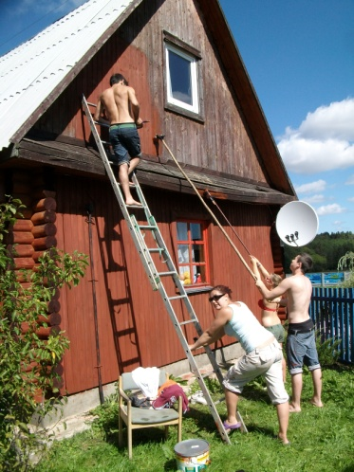

**We provided 14 volunteers throughout July and August, a combination of local 6th form students and past volunteers. The students were both child care and maintenance volunteers to help run the Summer camp and keep it looking fantastic!**

**The child care volunteers succeeded once again in maintaining the level of care and fun filled activities that the children have come to expect from the international volunteer team. The maintenance volunteers exceeded expectations of the hospice staff by repainting the entire front wall as well as preserving all the wooden buildings and adding even more colour to the vibrant interior of the camp, it really looks amazing!**

**Life on the camp provides the volunteers with life experience that we believe they will not get from anywhere else in the world. Our volunteer project is growing each year with more students showing interest and past volunteers wanting to return time and time again.**

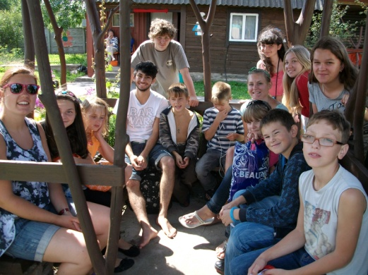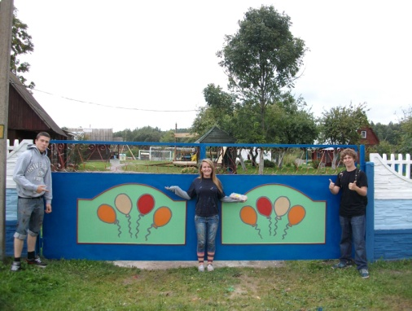

**As the Belarusian Children’s Hospice grows this year we are also taking a new direction within the Five Cs, we will be appointing a new team, that will be just as dedicated in supporting the hospice and all its programmes throughout the year, especially in providing volunteers for the Summer camp. We are hoping the project will develop, offering more and more students the opportunity to experience the wonderful people of Belarus and gain hands on experience of working with the children of the Belarusian Children’s Hospice.**

**Please see our website at** [**www.five-cs.org**](http://www.five-cs.org) **or our Facebook page (search Chernobyl Children Cancer Care Cardiff) for more information and photos and don’t hesitate to get in touch with any comments or questions!**

**We would like to thank all those that support us especially our incredible team of volunteers and we hope that we can count on your support with the upcoming changes of the Five Cs team!**